
LjunggrenAudio RYO Airtenuator
a floating passive attenuator

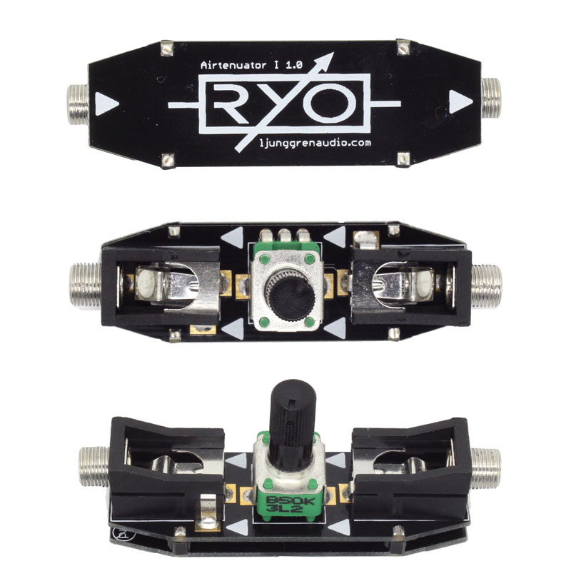

- floating passive attenuator.
- acting as a volume/modulation depth control.
- held up firmly by the two cables connected to it, the firm fit makes possible precise adjustments one-handed.
- easily twisted into an angle that works best for specific task / placement in patch.
- All analogue circuitry.
- One handed operation is tested on patch cables from Ad-Infinitum, Erthenvar (standard and IV) and TipTop Stackcables.
- Can handle any signal between -10V and +10V.
- low power draw: 0.2mA +12V / 0mA -12V / 0mA +5V required.
- Works for audio as well as CV.

downloads
* user manual
* quickstart guide
* assembly guide
* hi-res schematic
* datasheet
* BOM

